FEEDBACK TOPIC: Project Allowances

Date: February 2024

Question Asked:

I would like to ask this group a question on the Project Allowance and or Time away from Family Allowance Policy they follow in their organisation with example of how the amount is calculated.
I did check our resources repository on this but could not find one, hence the ask.

By Whom: Ramya Subbaraman, Compensation Specialis – APAC, Cubic Corporation

Answer | Provided by (please include name, position and company)
I suggest you check to see what provisions are included in the applicable Award or Site Agreement applicable to where the work is being conducted.  These often contain specific minimum provisions to be granted. You can also access the ATO which has specific payment guidelines applicable to remote work which can be used a basis for determining an appropriate rate. | Peter Way  HR Manager  Comms Group
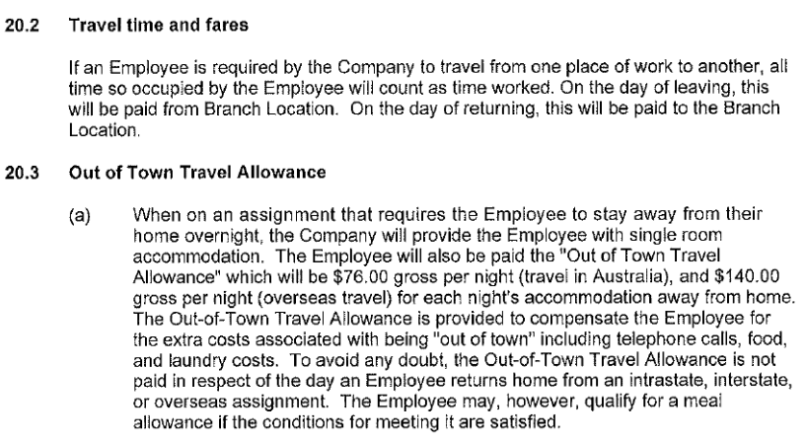 | Sally Miller  People & Culture Manager  Cycling New Zealand  Eke Paihikara Aotearoa

